1.Open Docker Desktop and make sure it’s running.

2.Pull the Gitea Docker image:

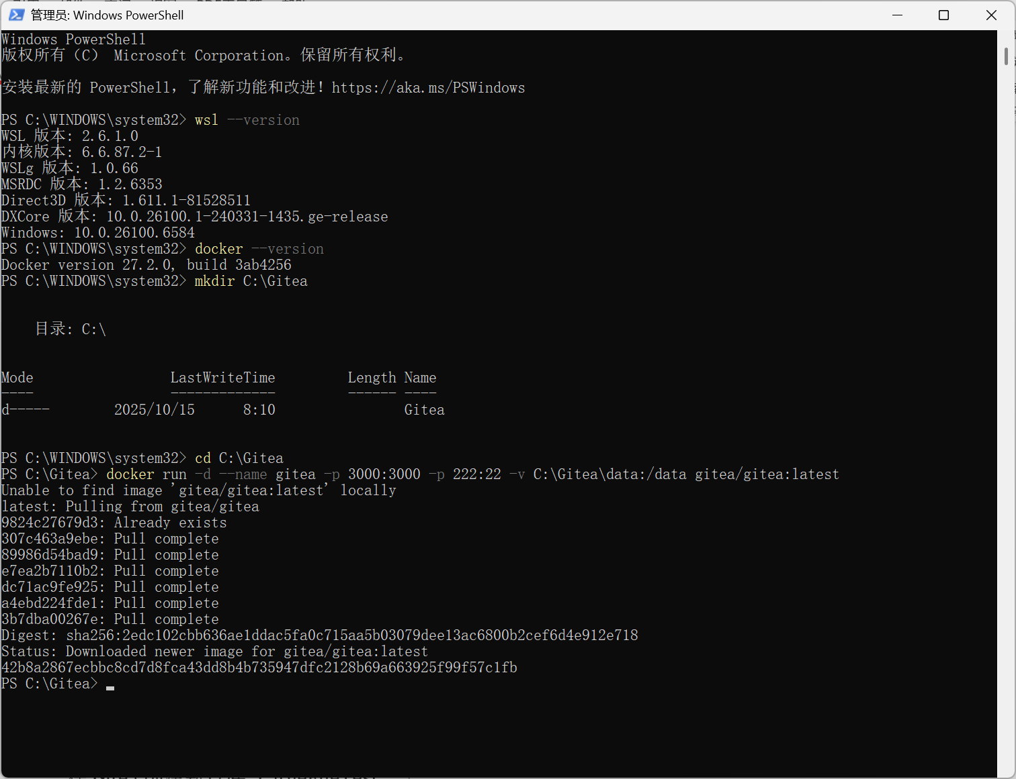

2. Pull and run the Gitea container

mkdir C:\Gitea  
cd C:\Gitea  
docker run -d --name gitea -p 3000:3000 -p 222:22 -v C:\Gitea\data:/data gitea/gitea:latest  


3. Open browser: <http://127.0.0.1:3000>

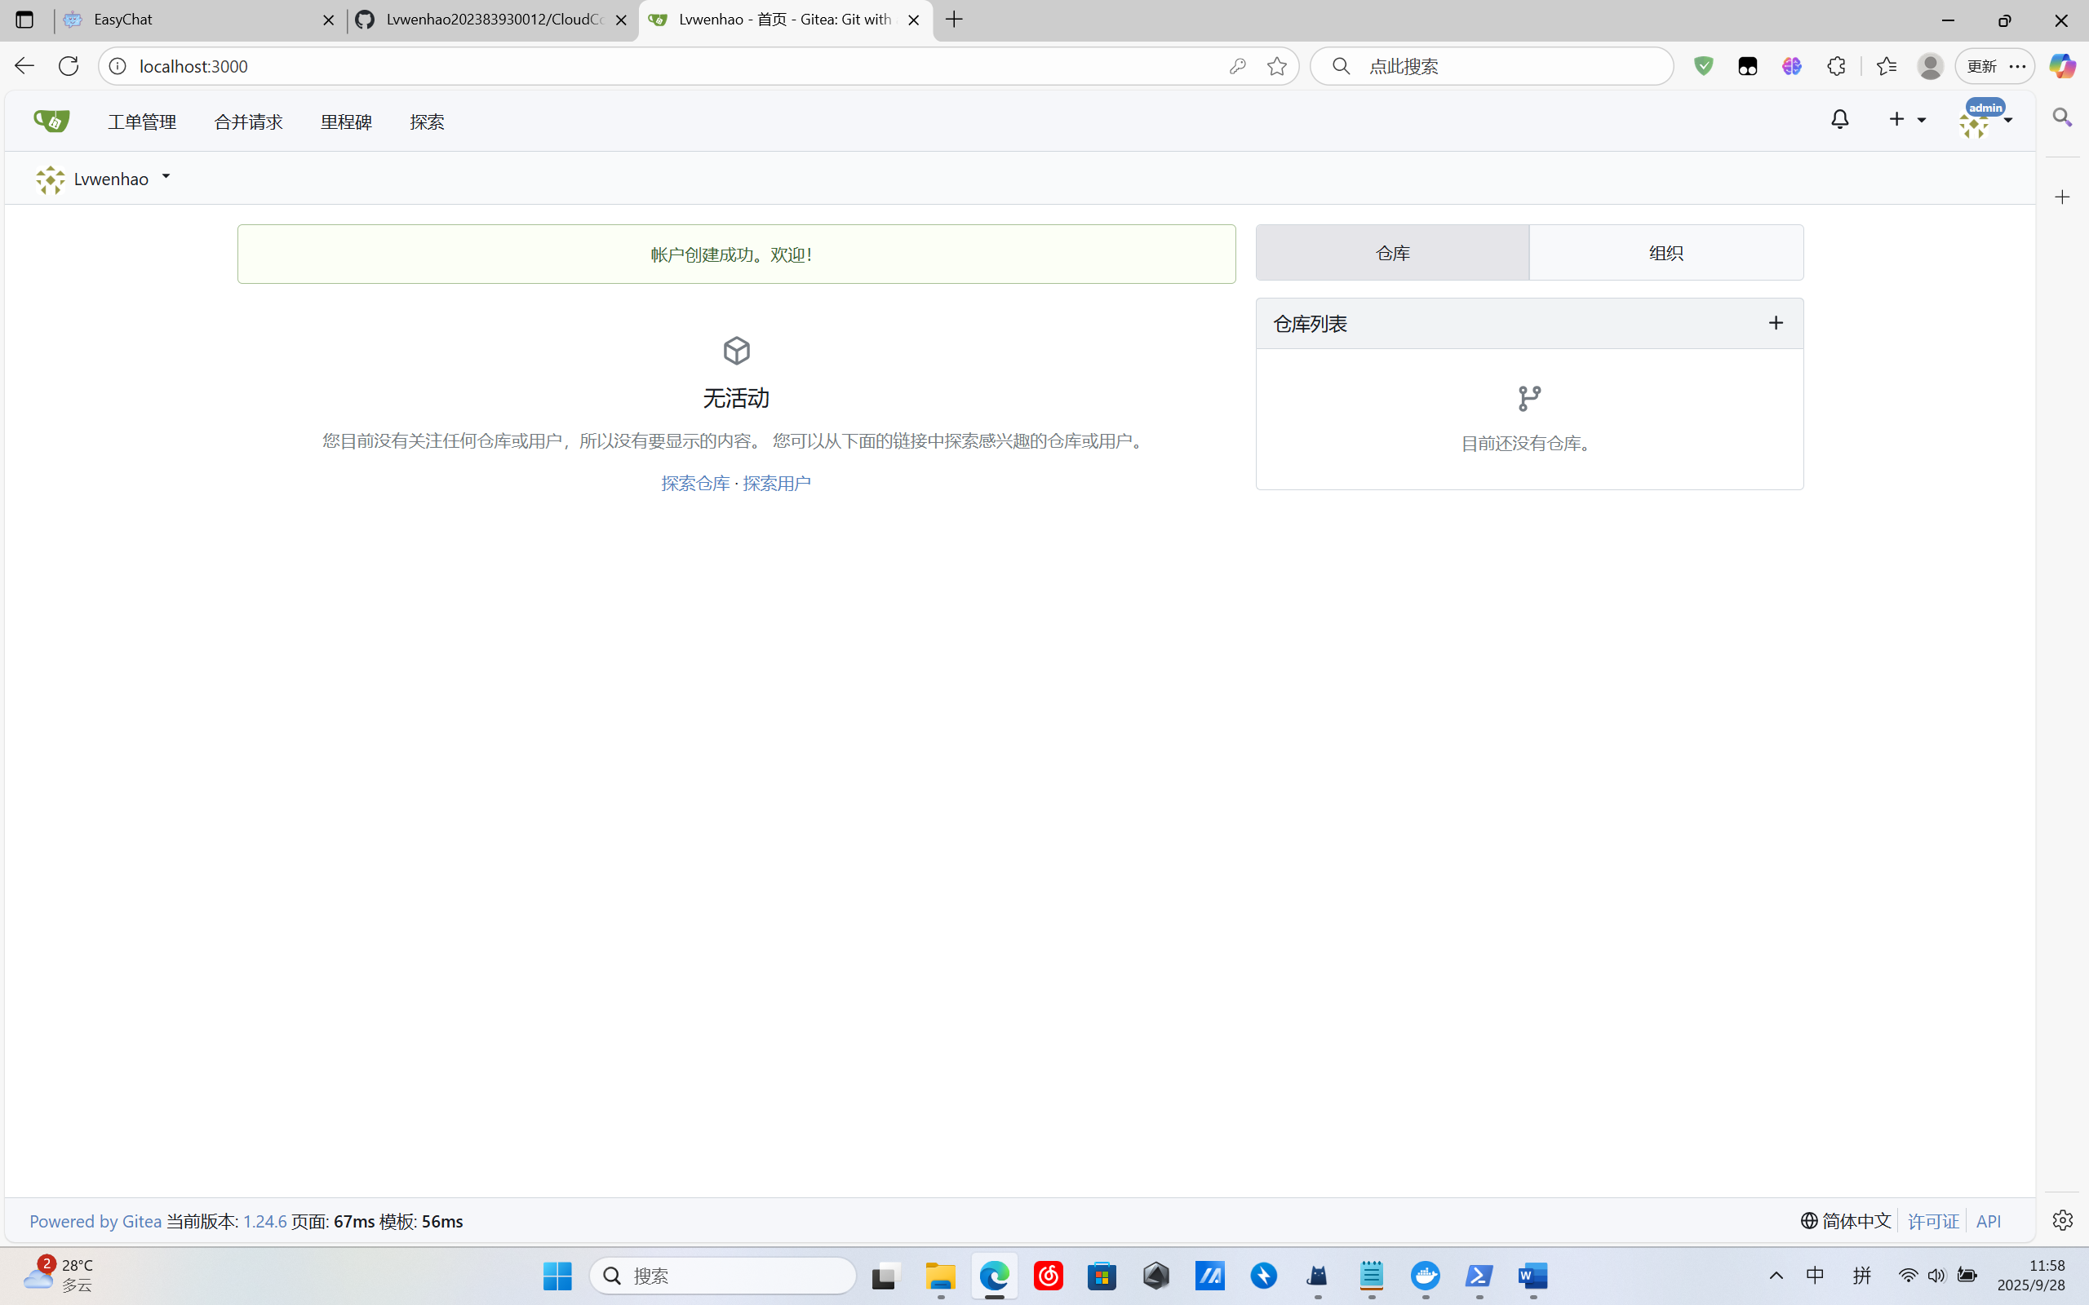

1. It support LFS

In docker edit config file

docker exec -it gitea /bin/sh vi /data/gitea/conf/app.ini

[server]

LFS_START_SERVER = true

We can find this on website

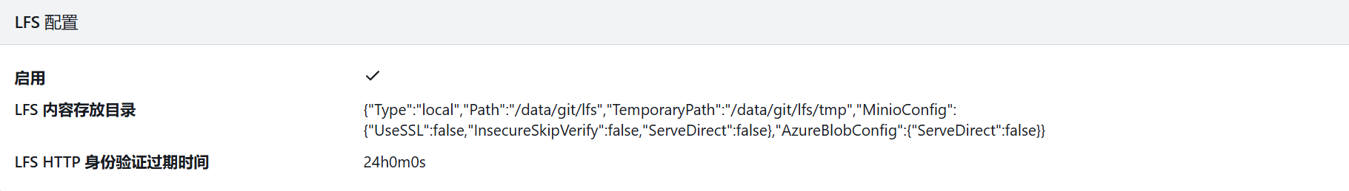

1. Create a test repository and upload large files

Create a new repository, `LargeFileTest`, in Gitea.

Use PowerShell to create a 1GB file: `fsutil file createnew bigfile.bin 1073741824`.

Then execute:

```  
git init  
git lfs install  
git remote add origin http://127.0.0.1:3000/<用户名>/LargeFileTest.git  
git add bigfile.bin  
git commit -m 'Add large file test'  
git push origin master  
```

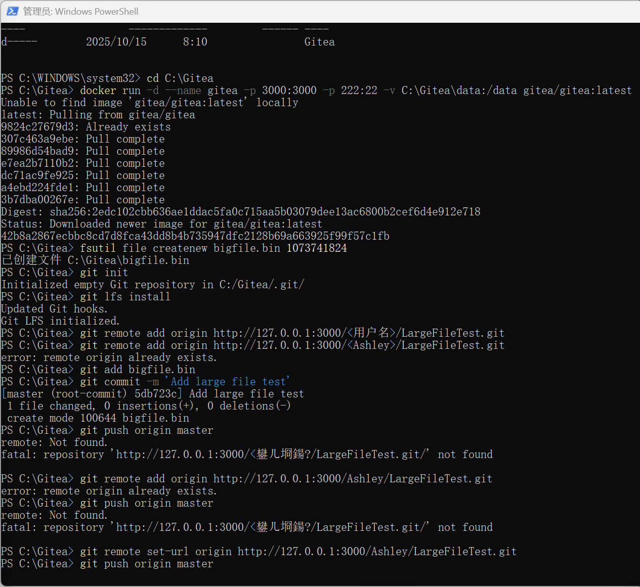

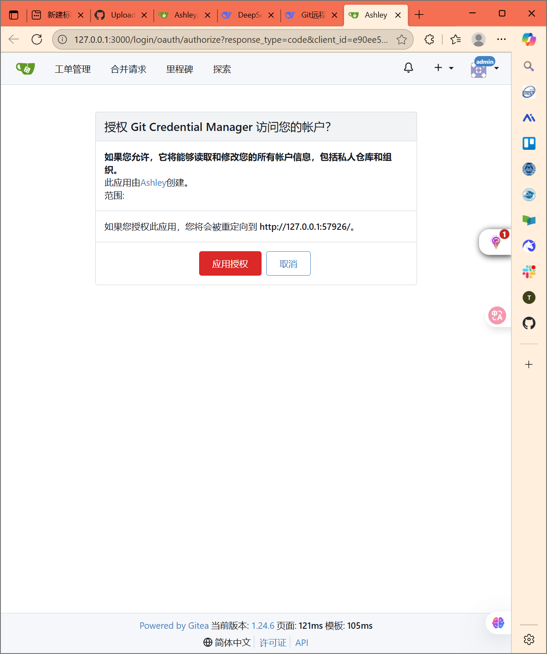

4. Create a dedicated repository for this course

Create a repository `CloudComputingModule` in Gitea and upload some Lab report files

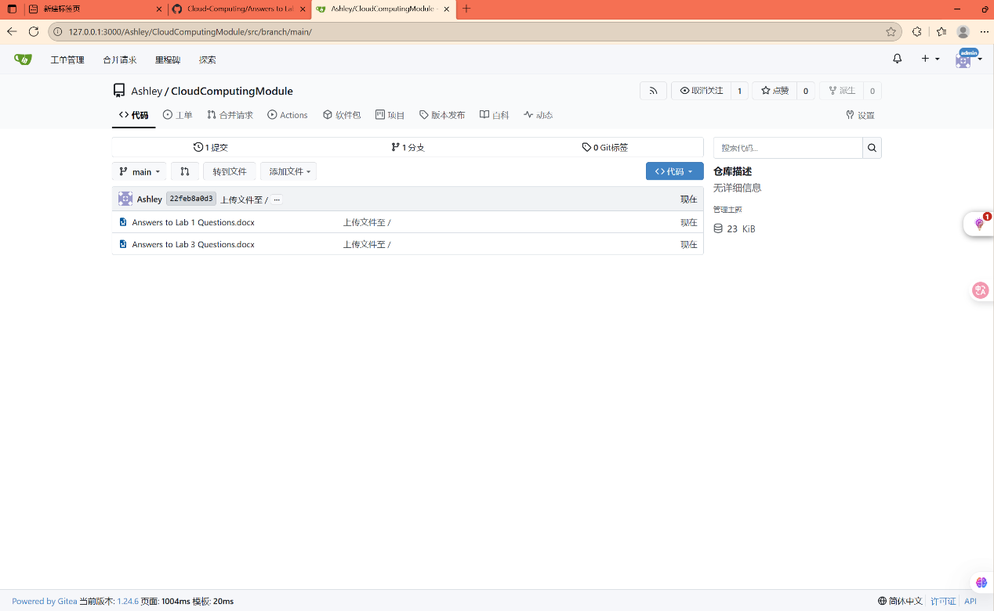

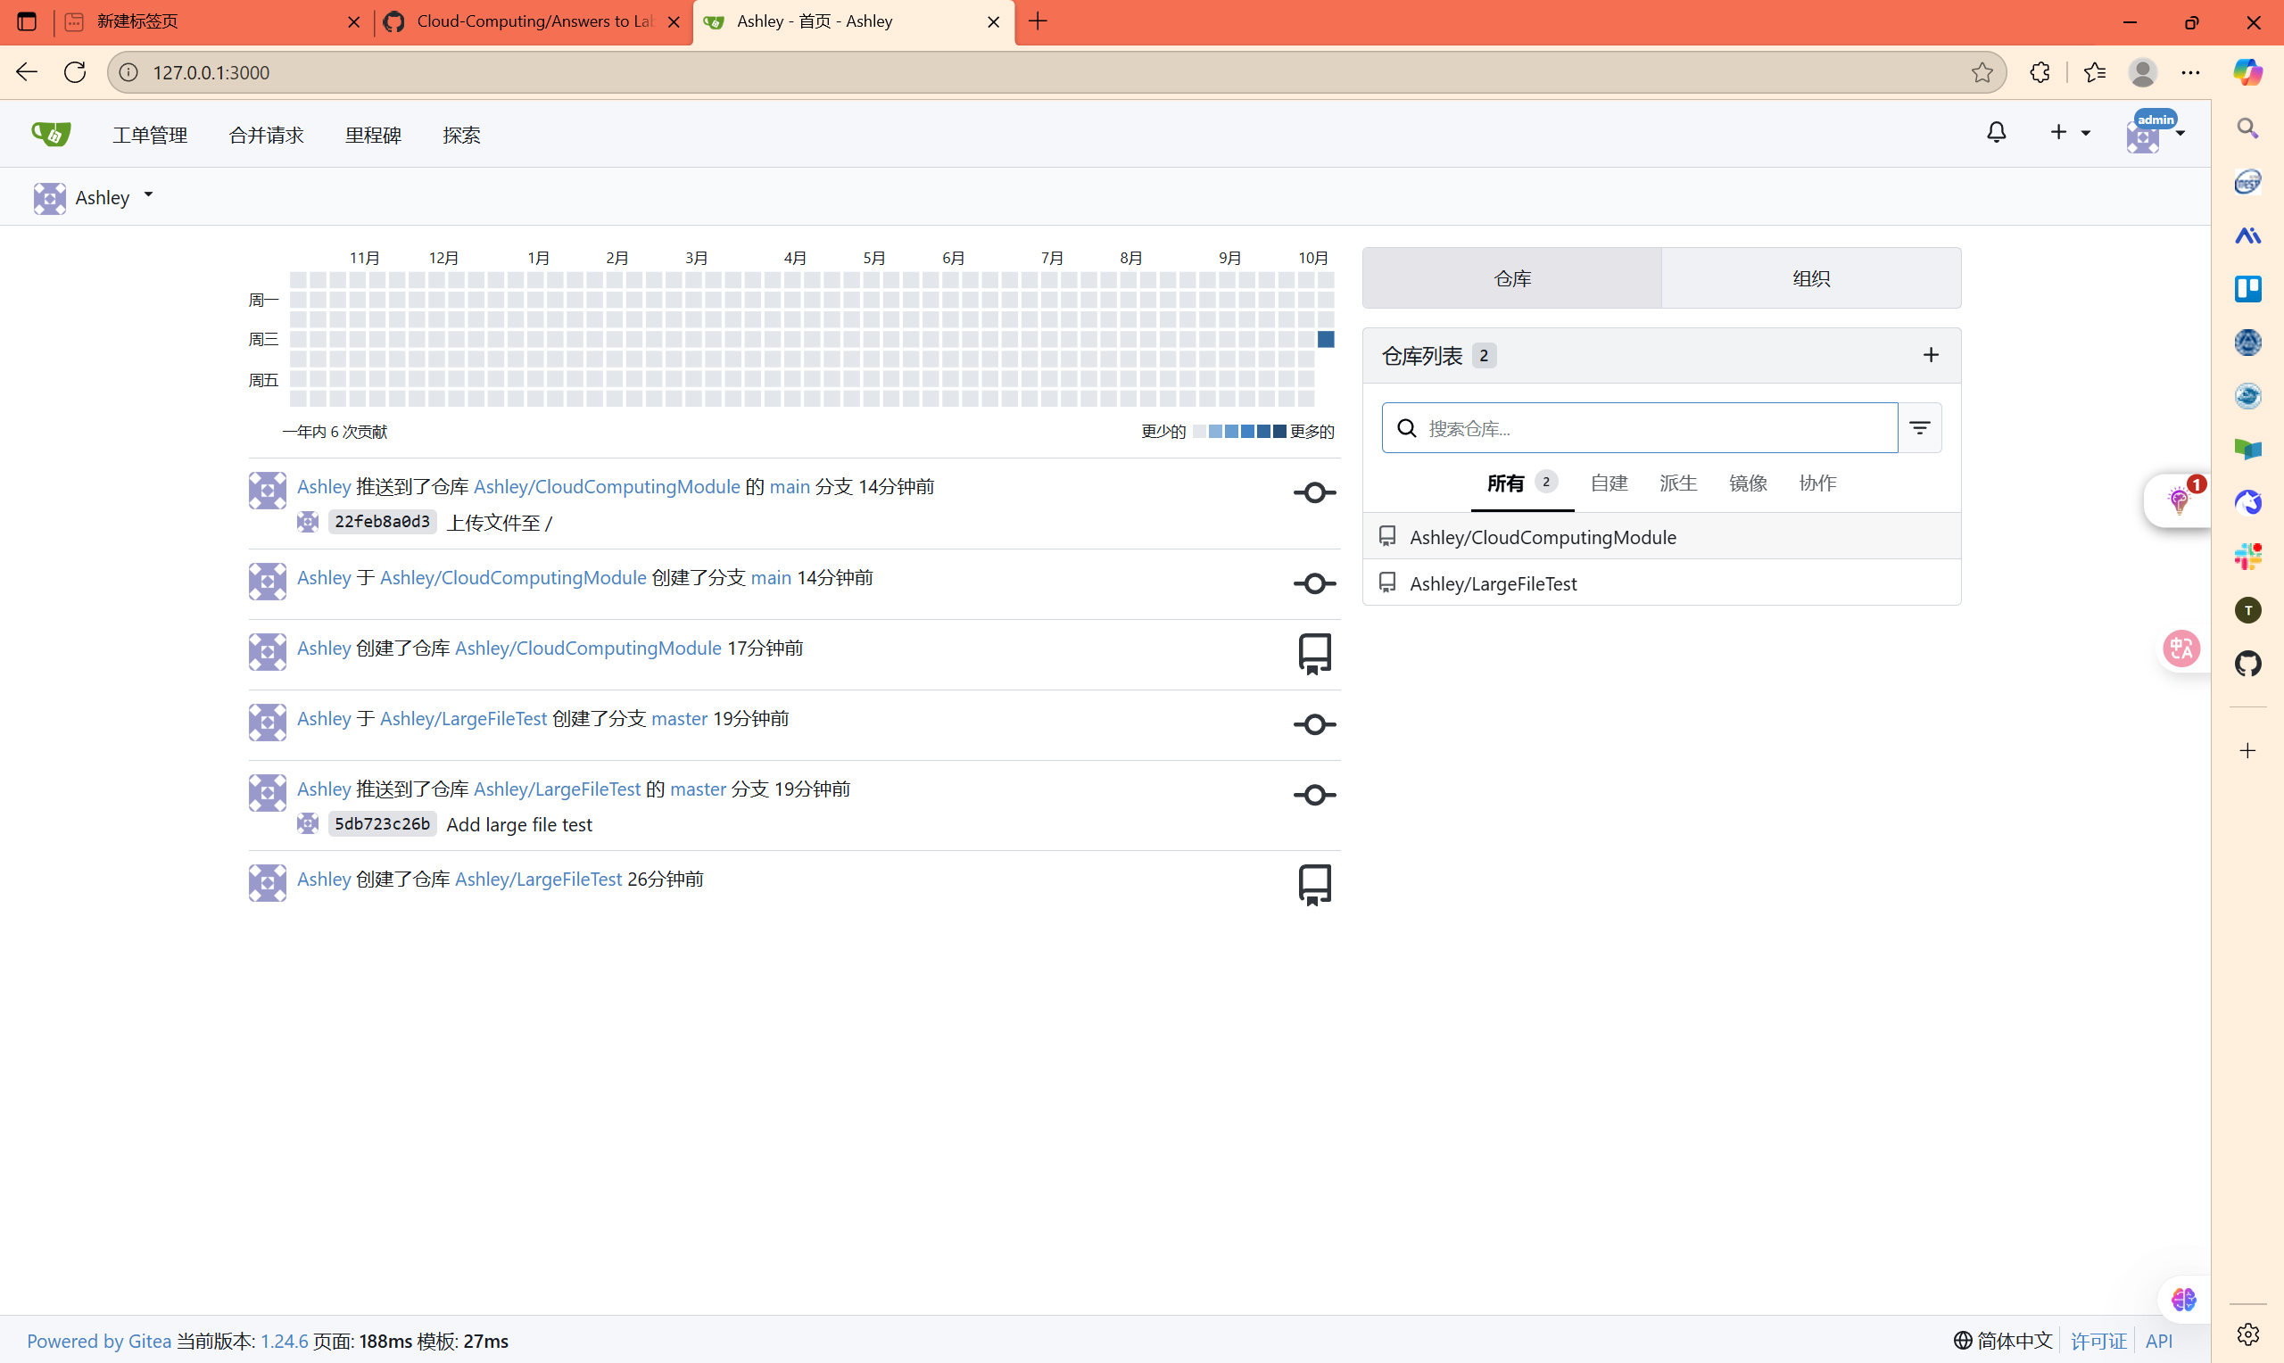

5. Backup and Recovery

Backup:

```

docker stop gitea

xcopy C:\Gitea\data D:\GiteaBackup /E /H /I /Y

```

Restore:

```

xcopy D:\GiteaBackup C:\Gitea\data /E /H /I /Y

docker start gitea

```

